SQL-QUERIES

1. Set Theory & Logical Operators , Equi-join Operations.
2. Aggregate Functions, Group by and Having ClauseTheory.
3. Views, single row , Multiple row & Correlated operations.

PL/SQL-QUERIES

1. Triggers
2. Cursors
3. Procedures
4. Functions

* Problem-Statements Of SQL :-
* Set Theory & Logical Operators , Equi-join Operations.

1. Retrieve player names of teams Australia and India using set operation UNION.

QUERY:-

select player_id,player_name

from player

where player_id like 'IND%'

union

select player_id,player_name

from player

where player_id like 'AUS%' ;

OUTPUT:-

P.T.O

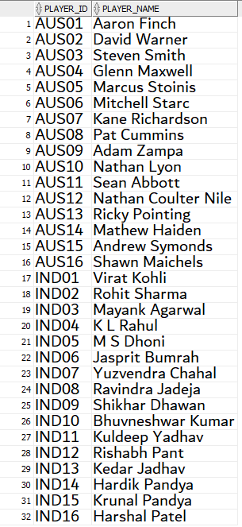

1. Retrieve names of the players from Australia and India who have played more than 50 test matches.

QUERY:-

select player_id,player_name

from player

where player_id like 'IND%' and No_of_tests >50

union

select player_id,player_name

from player

where player_id like 'AUS%' and No_of_tests >50;

OUTPUT:-

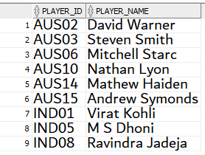

1. Retrieve names of the umpires who have umpired the matches from 1 to 15 in the world cup and have umpired more than 75 matches in their career.

QUERY:-

select u_name

from umpire

where number_of_matches > 100

intersect

select u.u_name

from umpire u,umpired_by m

where u.u_id=m.u_id and m.match_id between 1 and 15 ;

OUTPUT:-

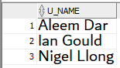

1. Retrieve names of the umpires who have umpired the matches from 1 to 15 in the world cup and have umpired more than 75 matches in their career.

QUERY:-

select u.u_name

from umpire u,umpired_by m

where u.u_id=m.u_id and u.number_of_matches > 100 and m.match_id between 1 and 15 ;

OUTPUT:-

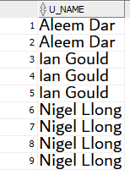

1. Retrieve coach name and to those who do not belong to India and have experience of coaching for more than 3 years.

P.T.O

QUERY:-

select coach_name,coach_country

from coach

where coach_country NOT LIKE 'India' and coach_experience > ANY (select coach_experience

from coach

where coach_experience > 4)

OUTPUT:-

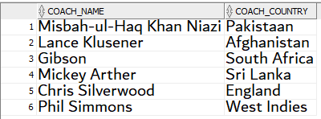

1. retrieve the names of the teams who are likely to qualify for the Semi-Final based on their current position in the points table where minimum points required to qualify is 10.

QUERY:-

select p.team_id ,p.points,t.country_name

from points_table p,team t

where p.team_id=t.team_id and points > any (select points

from points_table

where points = 8 );

OUTPUT:-

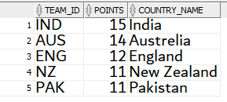

1. Consider the match between INDIA and AUSTRALIA retrive the stats of bowler who is medium paced,spin and Leg-Spin who bowls to these countries

QUERY:-

select p.player_name,b.economy

from player p ,bowler b

where p.player_id=b.player_id and

(b.player_id like 'IND%' or b.player_id like 'AUS%')

and

(b.bowler_type like 'Medium%' or b.bowler_type like 'Leg%' or b.bowler_type like 'Sp%' ) ;

OUTPUT:-

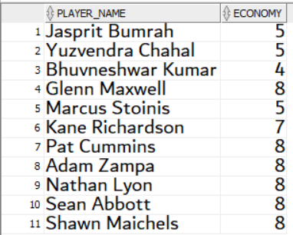

EQUI-JOIN Statements

1. Retrieve the entire schedule of the world cup along with the venue in which it is taking place.

QUERY:-

select m.*,s.stadium_name

from stadium s,matches m

where s.stadium_id = m.stadium_id;

OUTPUT:-

P.T.O

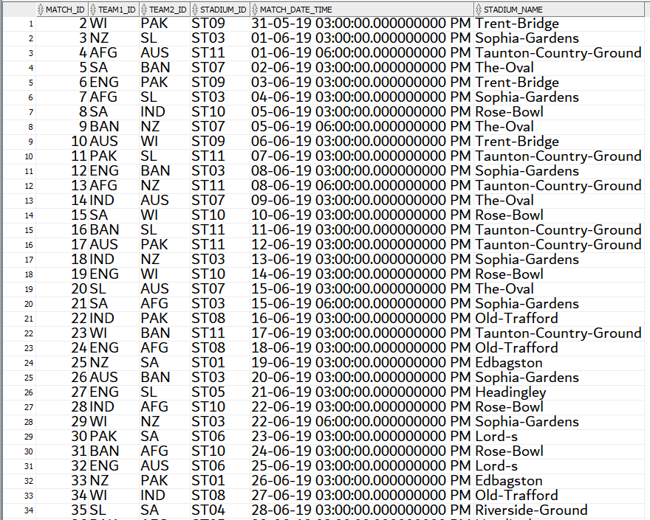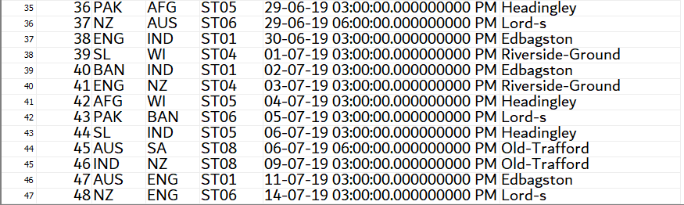

1. Retrieve the entire schedule of the world cup along with the venue in which it is taking place along with who won the match and by how many runs.

QUERY:-

select m.*,s.stadium_name,r.winner_team,r.won_by_runs_or_wickets

from stadium s,matches m,results r

where s.stadium_id = m.stadium_id and r.match_id=m.match_id;

OUTPUT:-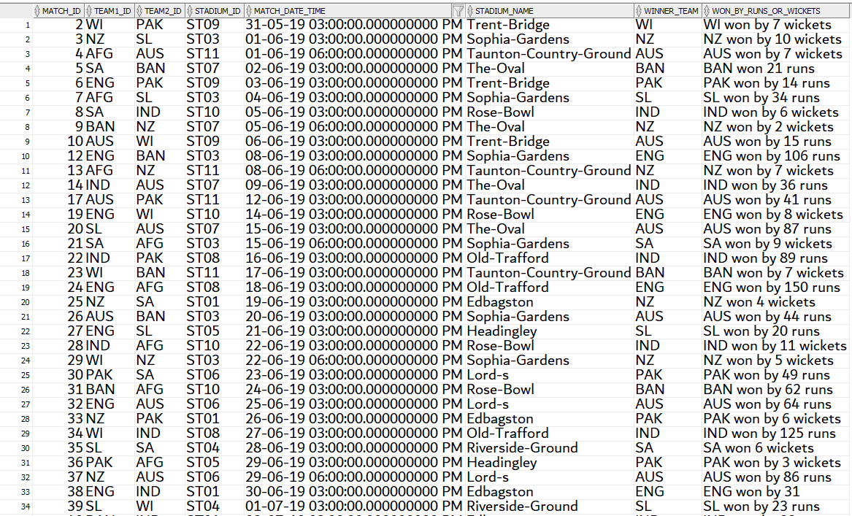

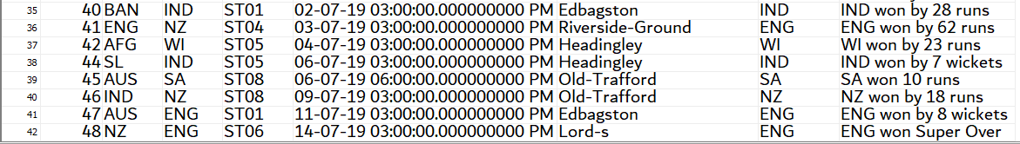

1. Retrieve the entire schedule of world cup along with the venue in which it is taking place along with who won the match and by how many runs and man of that match.

QUERY:-

select m.*,s.stadium_name,r.winner_team,r.won_by_runs_or_wickets,p.player_name

from stadium s,matches m,results r ,player p

where s.stadium_id = m.stadium_id and r.match_id=m.match_id and r.man_of_the_match=p.player_id;

OUTPUT:-

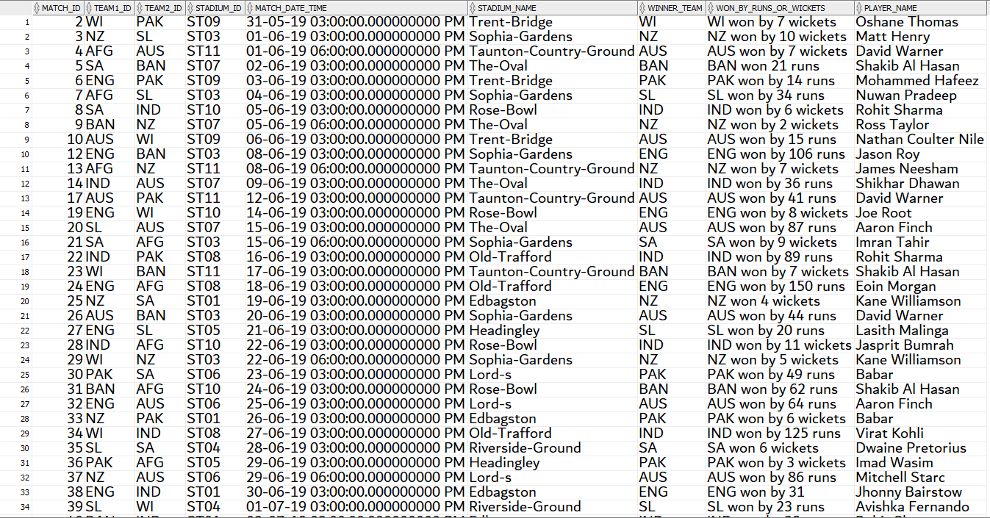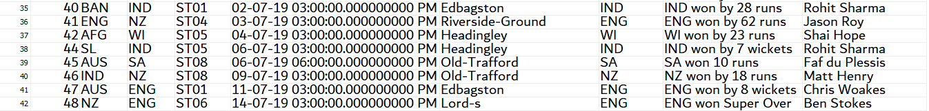

1. Retrieve details of the team along with their respective coaches and captains who belong to their respective countries.

QUERY:-

select T.team_id,T.Country_name,C.player_id,C.Name as Captain_Name,P.type_of_player ,CO.Coach_name

from team T,captain C,Coach CO,player P

where T.team_id=C.Team_id and t.team_id=co.team_id and C.player_id=P.player_id ;

OUTPUT:-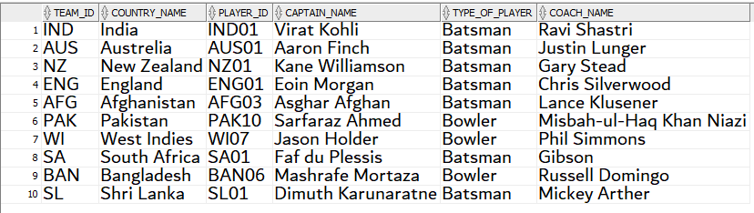

1. Retrieve the names of the players who are all rounders of Australia along with their stats.

QUERY:-

select p.player_name,p.type_of_player,ba.highest_runs,ba.batting_average,bo.number_of_wickets,bo.economy

from player p,batsman ba,bowler bo

where p.player_id=ba.player_id and p.player_id like 'AUS%' and p.player_id=bo.player_id and ba.player_id=bo.player_id;

OUTPUT:-



* Aggregate Functions, Group by and Having ClauseTheory.

1. Display the number wins,loss and draw,points and team rank of 2 teams with least run_rate*/.

QUERY:-

select * from(select * from points_table order by run_rate asc)

where rownum<=2;

OUTPUT:-



1. Retrieve the list of stadiums and no.of matches played in each stadium.

QUERY:-

select stadium_name,count(*)

from stadium s,matches m

where s.stadium_id=m.stadium_id

group by stadium_name

order by count(*) asc;

OUTPUT:- P.T.O

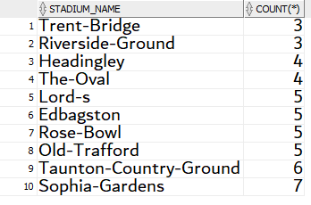

1. Display the list of umpires who umpired matches IN WorldCup in which the winning team must be INDIA.

QUERY:-

SELECT U_NAME,m.match_id,COUNT(*)

FROM UMPIRE U,UMPIRED_BY UB,matches m

where u.u_id=ub.u_id and ub.match_id=m.match_id and m.match_id in (select r.match_id from results r where r.winner_team='IND')

group by u_name,m.match_id

order by m.match_id;

OUTPUT:-

P.T.O

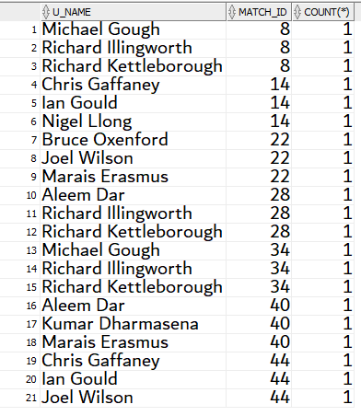

1. Display list of player_name,bowler_type top 10 highest bowling speed.

QUERY:-

select * from(select p.player_name,b.bowler_type,b.highest_speed from player p,bowler b where p.player_id=b.player_id order by b.highest_speed desc)

where rownum<=10;

OUTPUT:-

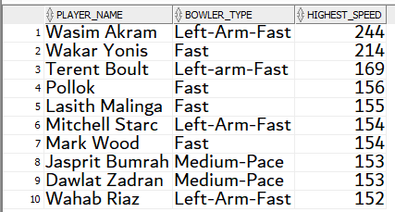

1. Retrieve the teams who have won more than 5 matches.

QUERY:-

select t.team_id,count(r.winner_team)

from team t,results r

where t.team_id=r.winner_team

group by t.team_id

having count(r.winner_team)>=5

order by count(r.winner_team);

OUTPUT:-

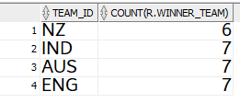

1. Retrieve the player details who have played more than 200 odi matches from IND.

QUERY:-

select p.player_id,p.type_of_player,p.no_of_odis,p.team_id

from player p

where p.team_id='IND'

having no_of_odis>=200

group by p.player_id,p.type_of_player,p.no_of_odis,p.team_id;

OUTPUT:-

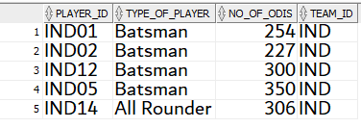

* Views, single row , Multiple row & Correlated operations.

1. Views.

a .Create a view of age_info which contains the name, country and age of each player .

QUERY:-

create view age_info as

select p.player_name,t.country_name, trunc(round((sysdate -to_date(p.dob))/365.25,5))AS age

from player p,team t,dual

where p.team_id=t.team_id and trunc(round((sysdate -to_date(dob))/365.25,5))>35;

select * from age_info;

OUTPUT:-

P.T.O

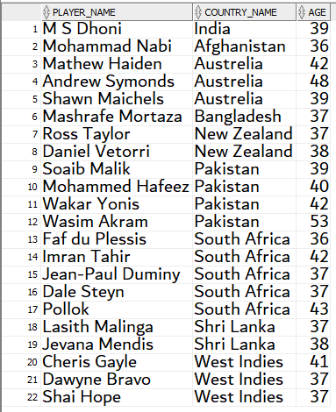

b .Create a view match_info which contains name, country and number of odis played where odis played is more than 150 .

QUERY:-

create view match_info as

select p.player_name,t.country_name,p.no_of_odis

from player p,team t

where p.team_id=t.team_id and p.no_of_odis>150;

select * from match_info;

OUTPUT:-

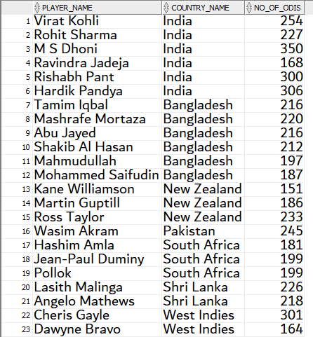

c .Create a view wickets_info which contains name, country,economy,bowler type and number of wickets taken where number of wickets taken is more than 100.

QUERY:-

create view wickets_info as

select p.player_name,t.country_name,b.economy,b.bowler_type,b.number_of_wickets

from player p,bowler b,team t

where p.team_id=t.team_id and p.player_id=b.player_id and number_of_wickets>100;

select * from match_info;

OUTPUT:-

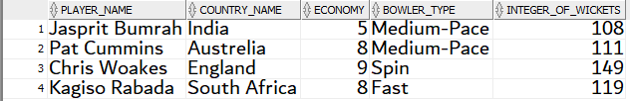

d .Create a view runs_info which contains all information of batsmans with their name who have scored more than or equal to 8000 runs.

QUERY:-

create view runs_info as

select p.player_name,b.*

from player p,batsman b

where p.player_id=b.player_id and b.total_runs>=8000;

select * from runs_info;

OUTPUT:-



e .Create a view IND_results which contains results of all matches played by india with name of man of the match.

P.T.O

QUERY:-

create view IND_results as

select r.* , p.player_name

from results r, player p

where r.man_of_the_match=p.player_id and r.match_id in(select match_id from matches where team1_id ='IND' OR team2_id ='IND');

select * from IND_results;

OUTPUT:-

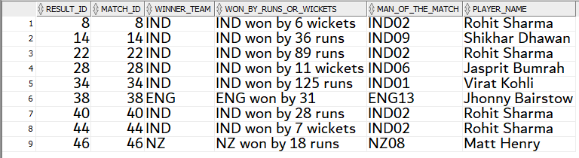

1. Single-Row.

a .Display the details of winning team with points.

QUERY:-

select a.*,p.*

from team a,points_table p

where a.team_id=p.team_id and a.team_id in(select r.winner_team from results r where r.match_id=48);

OUTPUT:-



b .Retrive the umpire_name,country, and his experience who has umpired the highest number of matches in World-cup.

QUERY:-

select * from (select u_name,u_country,u_experience,count(*)

from umpire u,umpired_by ub,matches m

where u.u_id=ub.u_id and ub.match_id=m.match_id

group by u_name,u_country,u_experience

order by count(*) desc)

where rownum<=1;

OUTPUT:-



c.Retrieve the details of the coach of team which won by 150 runs in match.

QUERY:-

select * from (select u_name,u_country,u_experience,count(*)

from umpire u,umpired_by ub,matches m

where u.u_id=ub.u_id and ub.match_id=m.match_id

group by u_name,u_country,u_experience

order by count(*) desc)

where rownum<=1;

OUTPUT:-



d.Retrieve the player details who played the highest no of ODIS.

QUERY:-

select *

from player

where no_of_odis=(select max(no_of_odis) from player);

OUTPUT:-

e.Retrieve the details of the match held on 14-jul-2019 and its results.

QUERY:-

select m.*,r.*,c.name

from matches m,results r,captain c

where m.match_id=r.match_id and c.team_id=r.winner_team and m.match_date_time like '14-JUL-19%';

OUTPUT:-



3.Multiple row & Correlated operations.

a .Retrieve the details of the umpires who have umpired matches in Sophia-Gardens.

QUERY:-

select distinct(u.u_id),u.u_name,u.u_country,u.number_of_matches,u.u_experience

from umpire u,umpired_by ub,matches m

where u.u_id=ub.u_id and ub.match_id=m.match_id and

m.match_id in (select match_id

from matches m1,stadium st1

where m1.stadium_id=st1.stadium_id and lower(stadium_name) like '%sophia%gardens%');

OUTPUT:-

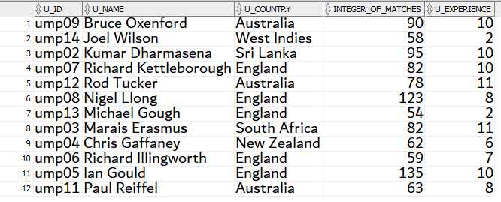

b .Retrieve the country whose players have the batting average greater than 90.

QUERY:-

select country_name

from team t

where team_id in(select team_id from player p,batsman b

where p.player_id=b.player_id and b.batting_average >90);

OUTPUT:-

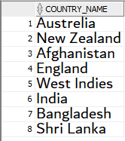

c .Retrieve the name of the captain who has won "man of the match" in at least one match.

QUERY:-

select cap.*

from captain cap,player p

where cap.player_id = p.player_id and p.player_id in (select res.man_of_the_match

from results res);

OUTPUT:-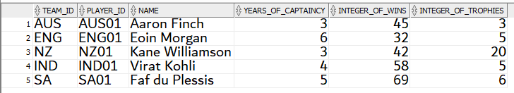

d .Retrieve the details and results of the matches that team India played in a stadium that has Batting-Pitch.

QUERY:-

select m.match_id,team1_id,team2_id,res.winner_team,res.won_by_runs_or_wickets,p.player_name

from matches m, results res, player p

where p.player_id = res.man_of_the_match

and (m.team1_id like 'IND' or m.team2_id like 'IND') and m.match_id = res.match_id and

m.match_id in (select match_id from matches m

where m.stadium_id in(select Stadium_id from stadium

where lower(pitch_type) like '%batting%pitch%'));

OUTPUT:-

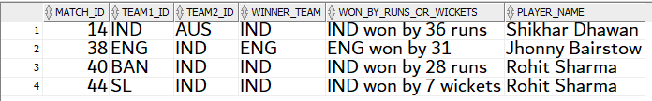

e .Retrieve the names of the coach and player who coached by him who has scored more than total runs of all the players coached by Lance Klusener.

QUERY:-

select (co.coach_id),co.coach_name,co.coach_country, p1.player_name

from coach co , player p1

where co.team_id = p1.team_id and

p1.player_id in (select player_id

from batsman

where total_runs > (select max(ba.total_runs)

from batsman ba,coach co,player p

where co.team_id=p.team_id and p.player_id = ba.player_id

and lower(co.coach_name) like '%lance%klusener%'))

order by co.coach_id;

OUTPUT:-

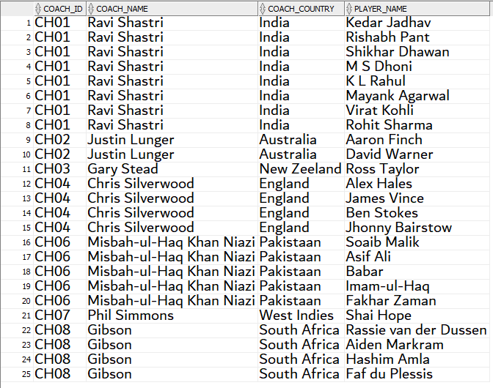

4.CORRELATED ROW SUBQUERIES.

a .Retrieve the details of the Batsmen who belong to the country same as that of Virat Kohli.

QUERY:-

select p.*,b.batsman_type,b.number_of_sixes,b.number_of_fours,b.total_runs,b.Highest_runs,b.batting_average

from player p,batsman b,team t

where p.player_id = b.player_id and

t.team_id = p.team_id and

exists (select *

from player p1,team t1

where t1.team_id = p1.team_id and lower(player_name) like '%virat%'

and t.country_name = t1.country_name);

OUTPUT:-

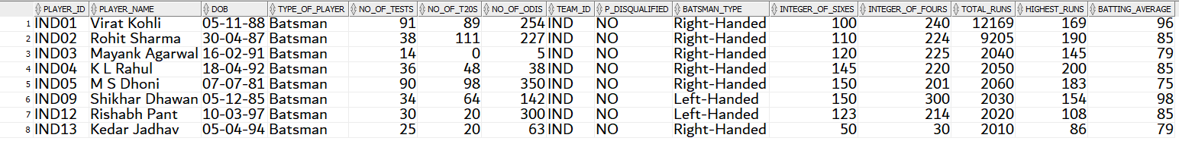

b .Retrieve the Match ids of matches umpired by Kumar Dharmasena and names of all the umpires who umpired the matches along with him.

QUERY:-

select distinct(u.u_name)

from matches m, umpired_by ub, umpire u

where m.match_id = ub.match_id and u.u_id = ub.u_id and lower(u.u_name) not like '%dha___sena%' and

exists (select distinct(m1.match_id)

from umpire u1,matches m1, umpired_by ub1

where m.match_id = m1.match_id and u1.u_id = ub1.u_id and

m1.match_id = ub1.match_id and lower(u1.u_name) like '%dha___sena%');

OUTPUT:-

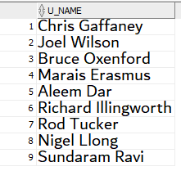

c .Details of the batsman whose total runs are greater than the average total runs of his own team.

QUERY:-

select p.player_id,p.player_name,ba.batsman_type,ba.total_runs,ba.number_of_sixes,ba.number_of_fours

from batsman ba, player p

where ba.player_id = p.player_id and

ba.total_runs > (select avg(ba2.total_runs)

from batsman ba2,player p2

where ba2.player_id = p2.player_id and p2.team_id = p.team_id);

OUTPUT:-

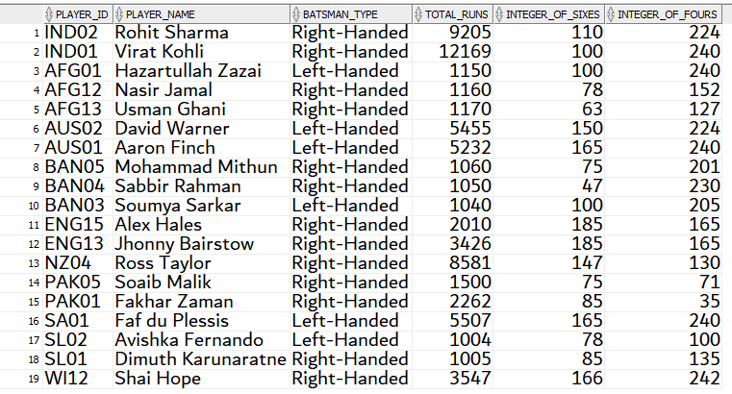

d.Details of the teams which have won more than 3 matches.

QUERY:-

select t.*

from team t

where team_id in(select res.winner_team

from results res

group by(winner_team)

having count(*)>4);

OUTPUT:-

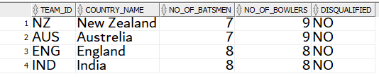

e.Details of the bowlers whose economy is greater than the average economy of his own team.

QUERY:-

select p.player_name,bo.*

from bowler bo, player p

where bo.player_id = p.player_id and

bo.economy > (select avg(bo2.economy)

from bowler bo2,player p2

where bo2.player_id = p2.player_id and p2.team_id = p.team_id);

OUTPUT:-

P.T.O

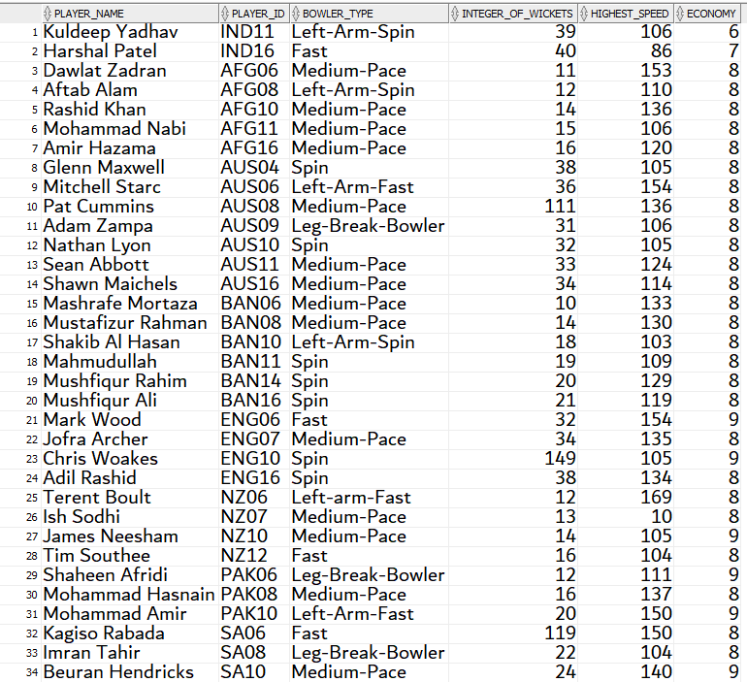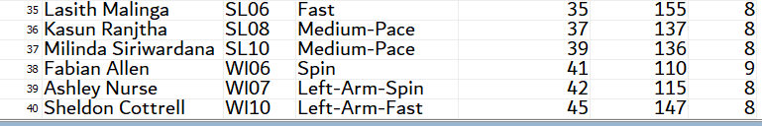

* Problem-Statements Of PL/SQL :-
* Triggers

1 : When a team is eliminated, do the necessary process and update the elimination table.

/*

drop table elimination;

create table elimination

(

team_id varchar2(30) primary key,

country_name varchar2(30),

no_of_batsmen number,

no_of_bowlers number

);

set serveroutput on

create or replace trigger eliminate_team

after delete on team

referencing new as new old as old

for each row

begin

insert into elimination values (:OLD.team_id ,:OLD.country_name,:OLD.no_of_batsmen ,:OLD.no_of_batsmen);

END;

/

delete from team where team_id='BAN';

select *from elimination ;

*/

--------------

OUTPUT:-

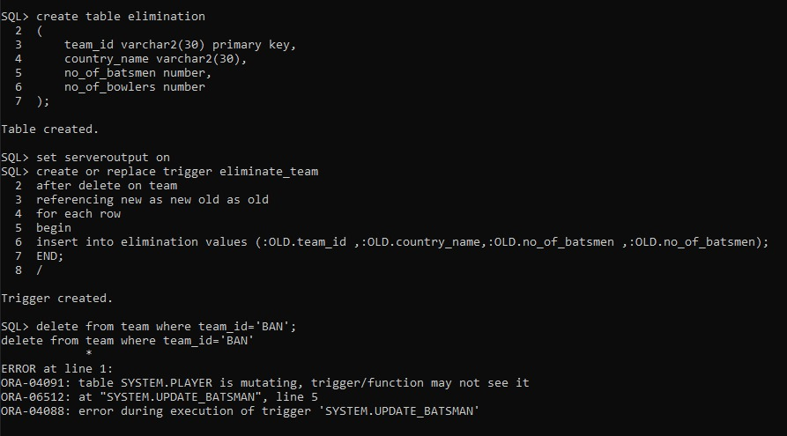

2 : Prevent a user from adding a BOWLER to the BATSMAN table.

/*

CREATE OR REPLACE TRIGGER update_batsman

BEFORE INSERT OR UPDATE ON batsman

FOR EACH ROW

DECLARE

player_type varchar2(50);

not_a_batsman EXCEPTION;

BEGIN

SELECT type_of_player INTO player_type FROM player

WHERE player_id = :new.player_id;

IF (player_type like 'Bowler') THEN

RAISE not_a_batsman;

END IF;

EXCEPTION

WHEN not_a_batsman THEN

Raise_application_error (-20300,'Entered player is not a Batsman');

WHEN NO_DATA_FOUND THEN

Raise_application_error(-20322,'Player does not exists');

END;

/

insert into batsman values('NZ12','Right-Handed',63,127,7000,94,85);

delete from batsman where player_id='NZ12';

*/

OUTPUT:-

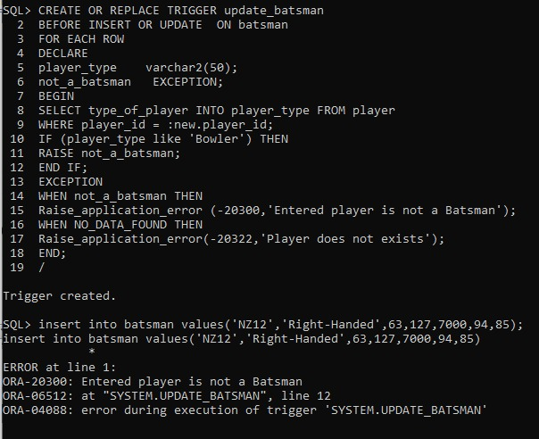

* Cursors

1 : Write down a cursor to obtain ID Of Team and Player along with the player name.

#include <stdio.h>

main(int argc, char *argv[])

{

if (vfork() == 0)

execvp(argv[1], &argv[1]);

printf("Parent Process\n");

}

declare

cursor c1 is select team_id,player_id,name from captain;

t_id captain.team_id%type;

p_id captain.player_id%type;

name captain.team_id%type;

begin

open c1;

dbms_output.put_line('TEAM_ID PLAYER_ID NAME'||chr(13)||chr(10));

loop

fetch c1 into t_id,p_id,name;

exit when c1%notfound;

dbms_output.put_line(t_id||' '||p_id||' '||name);

end loop;

close c1;

end;

/

OUTPUT:-

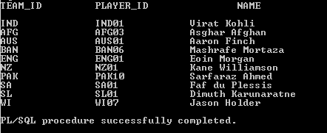

2 : Write down to a cursor to implement and obtain ID of both Coach and Team along with to which country the coach belongs and his respective name.

declare

cursor c1 is select coach_id,team_id,coach_name,coach_country from coach;

id coach.coach_id%type;

team coach.team_id%type;

name coach.coach_name%type;

t coach.coach_country%type;

begin

open c1;

dbms_output.put_line('C_ID T_ID COUNTRY NAME'||chr(13)||chr(10));

loop

fetch c1 into id,team,name,t;

exit when c1%notfound;

dbms_output.put_line(id||' '||team||' '||t||' '||name);

end loop;

close c1;

end;

/

OUTPUT:-

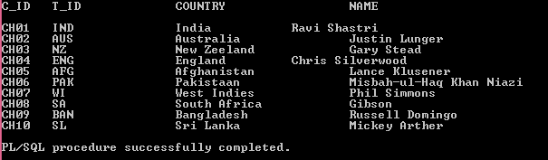

* Procedures

1 : Any player name given , Write a procedure to display whether he is a batsman or bowler and to which country he belongs.

create or replace PROCEDURE Displayplayer(pname VARCHAR2)

IS

tp player.type_of_player%TYPE;

tn team.country_name%TYPE;

BEGIN

SELECT p.type_of_player,t.country_name INTO tp, tn

FROM player p join team t on t.team_id=p.team_id

WHERE player_name=pname;

DBMS_OUTPUT.PUT_LINE('Type : '||tp);

DBMS_OUTPUT.PUT_LINE('Team NAme : '||tn);

END Displayplayer;

EXEC Displayplayer('Virat Kholi');

EXEC Displayplayer('MS Dhoni');

EXEC Displayplayer('Marcus Stoinis');

EXEC Displayplayer('David Warner');

EXEC Displayplayer('Rashid Khan');

EXEC Displayplayer('Colin Munro');

OUTPUT:-

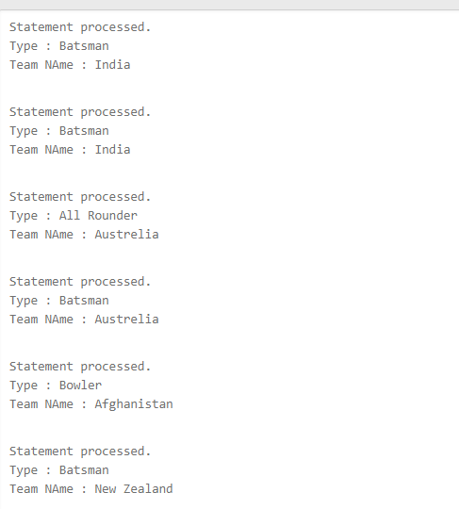

2 : Any match date given , Write a procedure to display the teams names between matches being held.

create or replace PROCEDURE matchdetails(matchdatetime timestamp)

IS

tp matches.team1_id%TYPE;

tq matches.team2_id%TYPE;

BEGIN

SELECT m.team1_id,m.team2_id INTO tp, tq

FROM matches m

WHERE match_date_time=matchdatetime;

DBMS_OUTPUT.PUT_LINE('Team1 is : '||tp);

DBMS_OUTPUT.PUT_LINE('Team2 is : '||tq);

END matchdetails;

EXEC Displayplayer('01-JUN-2019 03-00-00 pm');

EXEC Displayplayer('04-JUN-2019 03-00-00 pm');

EXEC Displayplayer('05-JUN-2019 06-00-00 pm');

EXEC Displayplayer('10-JUN-2019 03-00-00 pm');

EXEC Displayplayer('12-JUN-2019 03-00-00 pm');

EXEC Displayplayer('20-JUN-2019 03-00-00 pm');

OUTPUT:-

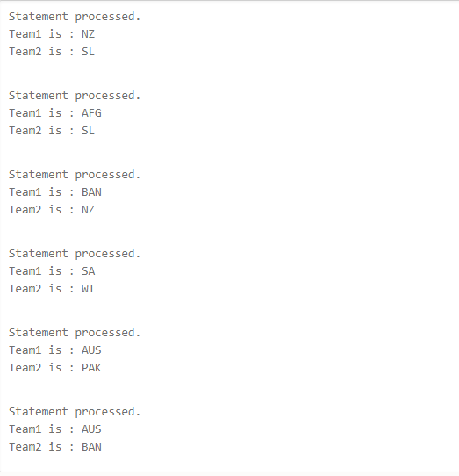

* Functions

1 : RETRIVE THE RUN RATE OF GIVEN TEAM ID

create or replace function r(teamid in string)

return number

as

r_r number;

begin

select run_rate into r_r from points_table

where points_table.team_id=teamid;

return r_r;

end;

/

declare

teamid varchar2(30);

runrate number;

begin

teamid:=&teamid;

runrate:=r(teamid);

dbms_output.put_line('Run_rate : '||runrate);

end;

/

OUTPUT:-

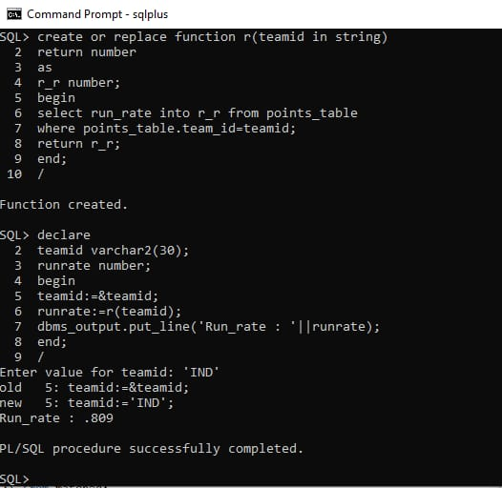

2 : RETRIVE THE NUMBERS MATCHES WON BY GIVEN TEAM IN WORLD CUP 2019.

create or replace function no_of_wins(teamid in string)

return number

as

wins number;

begin

select count(*) into wins from results

where winner_team=teamid;

return wins;

end;

/

declare

teamid varchar2(30);

wins number;

begin

teamid:=&teamid;

wins:=no_of_wins(teamid);

dbms_output.put_line('No of Matches Won by '||teamid||' are '||wins);

end;

/

OUTPUT:-

